Comparable Sales at Auction
(A collection of real auction sales for use in Nancy Stacy’s “Conquering Comps” workshop)

Sales of Round Brilliant Cut Diamonds with GIA Certs

1. Lot 53: A diamond single-stone ring

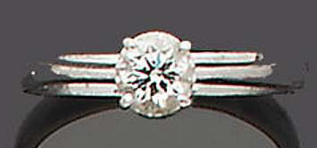
The brilliant-cut diamond, weighing 0.54 carats, within a four-claw setting, ring size L½ Accompanied by a certificate from the GIA stating that the diamond is an F colour and VS1 clarity. Certificate number 10492915. Dated 9th October 1998.
Price Realized: $ 1,182 £ 650
Bonham’s - London - Mar 1, 2006 - Jewellery

2. Lot 235: A diamond single-stone ring
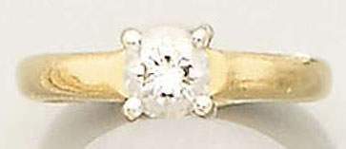
The brilliant-cut diamond, weighing 0.62ct., to a simple four claw mount, mounted in 18ct. yellow and white gold, hallmarked London, 2000, with maker's mark 'EF', finger size J ½. Accompanied by a certificate from the GIA stating that the diamond is D colour, VS2 clarity. Certificate number GIA 11123665 and dated 12th October 2000.
Price Realized: $ 1,636 £ 900
Bonham’s - London - Sep 28, 2005 - Jewellery

3. Lot 1226: Diamond Ring
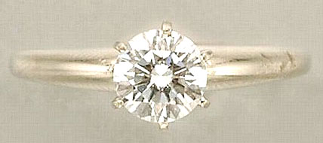
White gold, round diamond approximately 0.71 ct. With G.I.A. report stating diamond is F-VS2. Size 6 3/4. GIA certificate #11125011 October 23, 2000. F-VS2, faint fluorescence.

Estimate $1,800-2,200; Price Realized: $ 1,700
Doyle New York - New York - Apr 12, 2006 - Important Estate Jewelry

4. Lot 37: A diamond single-stone ring
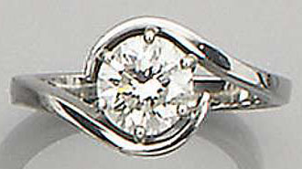
The brilliant-cut diamond, weighing 0.91ct.to a cross-over platinum mount, hallmarked London, 2003, finger size H. Accompanied by a certificate from the Gemmological Institute of America (GIA) stating that the diamond is G colour, SI1 clarity Certificate number 11976810, dated 7th May 2002
Estimate: £ 1,500 - £ 2,000
Price Realized: $ 3,260 - £ 1,793
Bonham’s - London - Apr 21, 2004 - Jewellery

5. Lot 16: PLATINUM AND DIAMOND RING, TIFFANY & CO
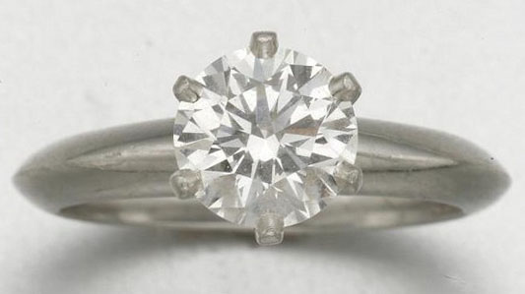
1 round-cut diamond weighs 1.01 cts, with GIA report stating G color, Internally Flawless; with Tiffany & Co. certificate and signed box,

Estimate: $ 3,000 - $ 5,000
Price Realized: $ 7,200

Sotheby's - New York - Oct 24, 2006; Arcade Jewels

6. Lot 147: b - A DIAMOND SOLITAIRE RING
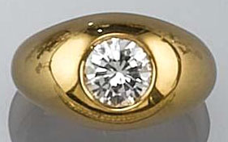
The collet-set brilliant-cut diamond weighing approximately 1.01 carats to a plain band, accompanied by a GIA certificate no. 7201802 dated 27 June 1991, stating the brilliant-cut diamond to be of a G colour and a VS1 clarity, ring size 15 3/4 mm (2).
Estimate: € 3,200 - € 4,700
Price Realized: $ 5,060; € 4,200

Sotheby's - Amsterdam - Jun 27, 2006, Fine Jewellery

7. Lot 164: A diamond and sapphire three-stone ring, by Tiffany and Co.
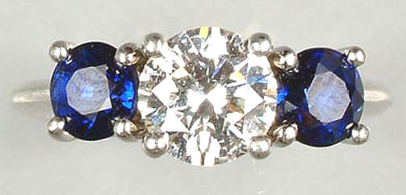
The central brilliant-cut diamond weighing 1.02 carats, with a circular mixed-cut sapphire either side, to a simple claw mount, signed Tiffany and Co., cased Accompanied by a certificate from the GIA stating that the diamond is E colour, VVS2 clarity. Certificate number 10163113, dated 2nd July 1997
Estimate: £ 3,000 - £ 4,000
Price Realized: $ 6,953 - £ 3,824
Bonham’s - London - Oct 2, 2003 - Fine Jewellery

8. Lot 607: Platinum and Diamond Ring
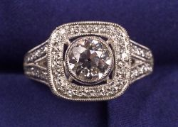
Description: set with an old European-cut diamond weighing 1.14 cts. the bezel, gallery, and shank set with ninety-one bead-set single-cut diamonds, size 6 1/4.Note: Accompanied by a certificate from the GIA dating March 15, 2004, stating the stone is G color, and VS1 clarity.
Estimate: $ 4,500 - $ 5,000; Price Realized: $ 5,581
Skinner, Inc. - Boston - Jun 15, 2004 - Fine Jewelry

9. Lot 211: b - A DIAMOND SOLITAIRE RING
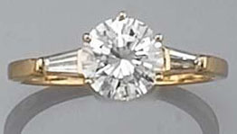
The central brilliant-cut diamond weighing 1.24 carats flanked by tapered baguettes, accompanied by a GIA certificate no. 5339187 dated 10 June 1991, stating the diamond to be of G colour and VVS2 clarity, marker's mark SB for Serge Bouder and French assay mark, ring size 16 1/4 mm (2).
Estimate: € 4,400 - € 6,700; Price Realized: $ 7,952; € 6,600
Sotheby's - Amsterdam - Jun 27, 2006; Fine Jewellery

10. Lot 290: DIAMOND RING, TIFFANY & CO.
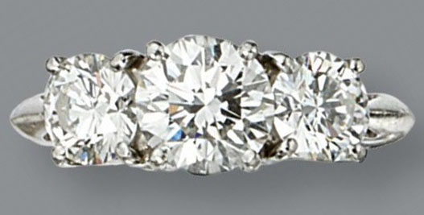
Set in the center with a round diamond weighing 1.46 carats, flanked by 2 round diamonds together weighing 1.46 carats, mounted in platinum, size 5½.
Accompanied by GIA report no. 10186878 stating that the 1.46 carat diamond is G color, VS1 clarity. Also accompanied by three diamond certificates from Tiffany & Co.

Estimate: $ 10,000 - $ 15,000; Price Realized: $ 16,800
Sotheby's - New York - Apr 25, 2006
Magnificent Jewelry

11. Lot 443: PLATINUM AND DIAMOND RING, CIRCA 1930
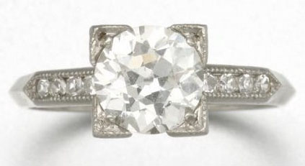
Size 5 ¼; 1 old European-cut diamond weighs 1.53 cts, with GIA certificate stating I color, SI1 clarity,

Estimate: $ 5,000 - $ 7,000
Price Realized: $ 6,300
Sotheby's New York - Oct 24, 2006; Arcade Jewels

12. Lot 325: DIAMOND RING
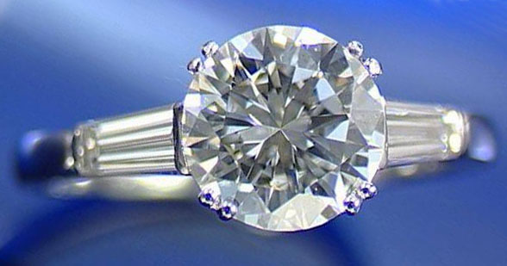
Set to the centre with a brilliant-cut diamond weighing 1.67 carats between tapered baguette diamond shoulders, K 1/2.
Accompanied by a certificated from the GIA, number 11925934, stating the diamond to be VVS2 clarity and H colour.

Estimate: £ 6,000 - £ 8,000
Price Realized: $ 12,000 - £ 6,600
Sotheby's - London - Dec 16, 2004
Fine Jewels

13. Lot 247: A D-colour, internally flawless diamond single-stone ring, by Tiffany & Co,
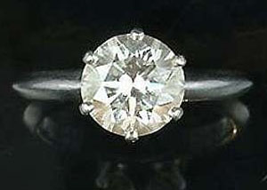
The claw-set brilliant-cut diamond, weighing 1.92 carats, signed Tiffany & Co and numbered, maker's case. Accompanied by a certificate from the GIA Gem Trade Laboratory stating that the diamond is D colour and internally flawless. Certificate number 8448106, dated 18th April 1994
Price Realized: $ 22,727 - £ 12,500
Bonham’s - London - Dec 9, 2004 - Fine Jewellery

14. Lot 152: A diamond single-stone ring,
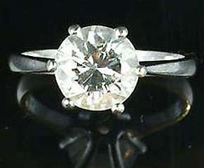
The brilliant-cut diamond, weighing 2.04 carats, to a simple claw setting, ring size J½
Accompanied by a certificate from the GIA stating that the diamond is F colour, VVS1 clarity. Certificate number 7089943, dated 09/09/88.
Price Realized: $ 27,273; £ 15,000

Bonham’s - London - Apr 7, 2005
Fine Jewellery

15. Lot 428: PLATINUM AND DIAMOND RING, TIFFANY & CO.
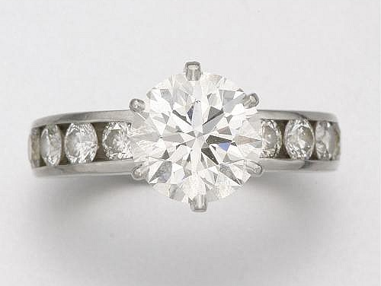
With GIA report stating diamond is 2.06 cts, H-VVS2, with signed box and Tiffany & Co. diamond certificate,
Dimensions size 4 1/2
$ 15,000 - $ 20,000
Price Realized: $ 24,000

Sotheby's - New York - Apr 25, 2007; Arcade Jewels

16. Lot 211: DIAMOND RING, TIFFANY & CO.
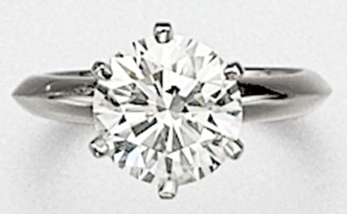
The round diamond weighing 2.28 carats, within a simple platinum mounting, size 3 3/4, signed Tiffany & Co. With box stamped Tiffany & Co. Accompanied by GIA report no. 12156930 stating that the diamond is I color, VS1 clarity. Also accompanied by a Tiffany & Co. diamond certificate.

Estimate: $ 12,000 - $ 15,000; Price Realized: $ 20,400
Sotheby's - New York - Jun 9, 2005 - Fine Jewelry

17. Lot 570: Diamond Three Stone Ring
Description: prong-set with a full-cut diamond weighing 2.52 cts. flanked by full-cut diamonds, approx. total wt. 3.18 cts. 18kt bi-color gold mount, size 6 3/4. Note: Accompanied by GIA certificate no. 11683177 dated August 29, 2001 stating that the diamond is F color, VS1 clarity.
Estimate: $ 20,000 - $ 25,000; Price Realized: $ 28,200
Skinner, Inc. - Boston - Dec 14, 2004
Fine Jewelry

18. Lot 265: A DIAMOND SINGLE STONE RING
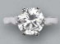
The brilliant-cut diamond weighing 3.00 carats to the plain white gold hoop. With certificate 10155004, dated 17 October 2000 from the GIA Gem Trade laboratory stating that the diamond weighing 3.00 carats is E colour, VS1 clarity (2)

Estimate: $ 27,250 - $ 32,700
Price Realized: $ 31,261
Christie's - Amsterdam - Apr 15, 2003 FINE JEWELLERY AND WATCHES

19. Lot 149: A PLATINUM THREE STONE DIAMOND RING
Set with one brilliant cut center diamond, measuring approximately 14.10mm x 14.25mm x 8.12mm, approximately 9.85 carats, SI1, K, GIA Certificate #5299204, flanked by two tapered baguette diamonds, approximately 7.5mm x 2.5mm x 2.5-1.7mm, approximately .80 carats.
Estimate: $ 50 - $ 50,000; Price Realized: $112,100

Dawson and Nye Auctioneers Appraisers - Morris Plains - Jan 24, 2007; Fine, Decorative Arts, Asian and Jewelry - Day 1

Sales of Old European Cut Diamonds

1. Lot 57: A DIAMOND AND PLATINUM RING
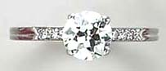
1 old European-cut diamond, weighing approximately 1.20 carats, J/K/L color, VVS-VS clarity; 6 single-cut diamonds; Size 8
Estimate: $2,500 - $3,000
Realized: $3,346
Christie's : New York: Mid Atlantic; Auction Date: Sep 14, 2004

2. Lot 632: A Platinum and Diamond Ring.
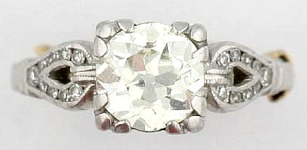
containing one old European cut diamond weighing approximately 1.20 carats, numerous small step cut diamonds weighing approximately 0.10 carat total. 2.70 dwt. Size 4 1/2 with sizer Color KL Clarity VS2 with two nicks in girdle. Open culet
Estimate: $1,000 - $2,000; Realized: $1,440
Leslie Hindman Auctioneers : Illinois: Midwest; Auction Date: May 21, 2006

3. Lot 46: A DIAMOND AND 14K WHITE GOLD RING
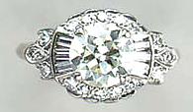
1 old European-cut diamond, weighing approximately 1.80 carats, M+ color, VVS-VS clarity
16 single and 6 baguette-cut diamonds
Size 7
Normal signs of wear
Estimate: $2,500 - $3,000; Realized: $3,107
Christie's : New York: Mid Atlantic; Auction Date: Sep 14, 2004

4. Lot 8: GOLD AND DIAMOND RING, CARTIER, CIRCA 1920
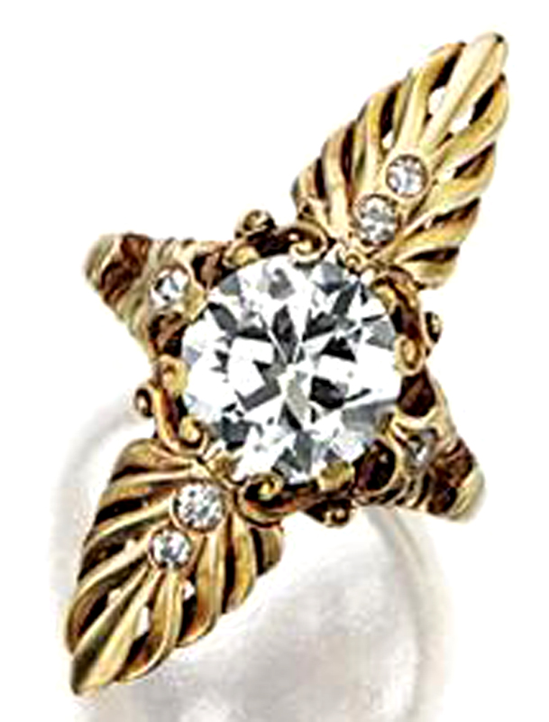
PROPERTY OF A NEW YORK PRIVATE COLLECTOR
The elongated navette-shaped mounting designed as palmette motifs centering an old European-cut diamond weighing 1.85 carats, further decorated with 6 small single-cut diamonds, size 3 3/4 , signed Cartier and 14K. Accompanied by GIA report no. 14588272 stating that the diamond is H color, VS1 clarity; together with original working diagram stating that the stone may be potentially flawless.
Estimate: $10,000 - $15,000; Realized: $16,800
Sotheby's : New York: Mid Atlantic; Auction Date: Dec 8, 2005

5. Lot 640: A DIAMOND AND 14 K GOLD RINGS
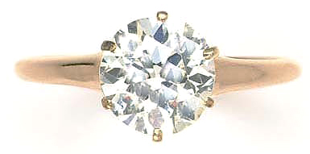
1 old European-cut diamond, weighing approximately 1.90-2.00 carats, I/J color, SI clarity, size 7, shows signs of normal wear
Estimate: $3,000 - $5,000
Realized: $4,560

Christie's : New York: Mid Atlantic; Auction Date: Jul 11, 2006 - Jul 12, 2006

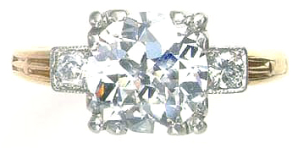
6. Lot 639: A DIAMOND, PLATINUM AND 14 K GOLD RINGS
1 old European-cut diamond, weighing approximately 2.25-2.50 carats, H/I color, VS-SI clarity, 2 old European-cut diamonds, good life and brilliance, size 7 3/4, shows signs of normal wear
Estimate: $8,000 - $12,000
Realized: $16,800
Christie's : New York: Mid Atlantic
Auction Date: Jul 11, 2006 - Jul 12, 2006

7. Lot 312: DIAMOND RING, CIRCA 1930
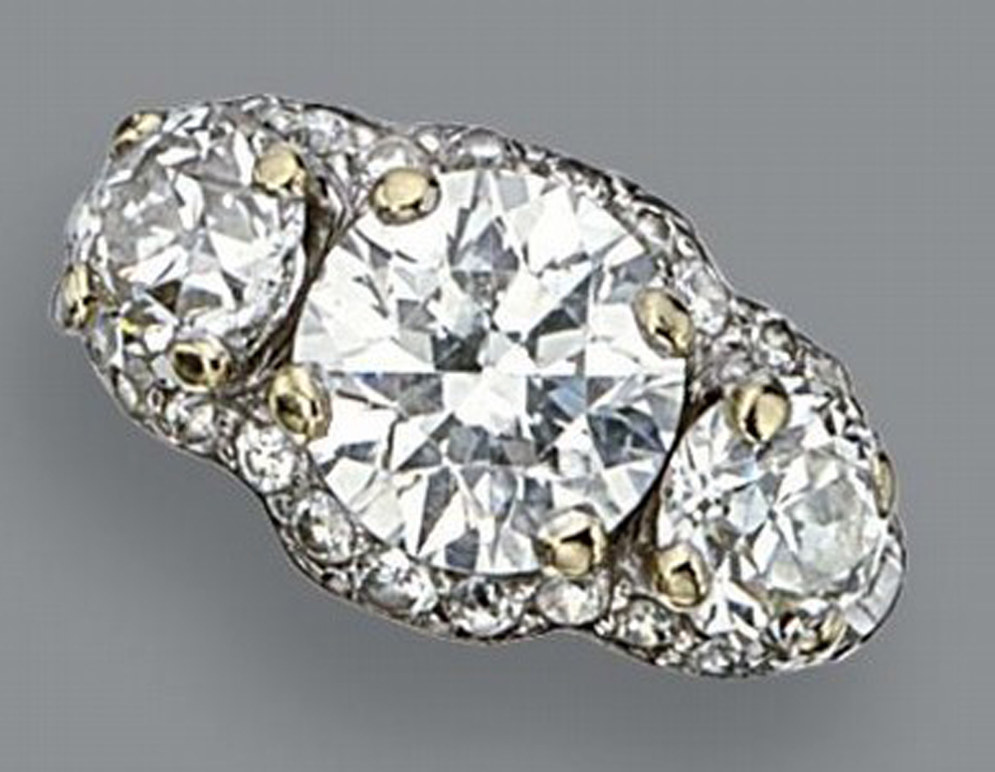
PROPERTY FROM THE ESTATE OF MARY WALDRON
Set in the center with an old European-cut diamond weighing approximately 2.45 carats, flanked by 2 old European-cut diamonds together weighing approximately 1.70 carats, framed by small old European-cut diamonds with baguette diamonds at the shoulders, mounted in platinum, size 6½.
Pre-Auction Price Estimate: $10,000 - $15,000
Price Realized: $32,400
Sotheby's : New York: Mid Atlantic; Auction Date: Apr 25, 2006

8. Lot 330: AN ART DECO DIAMOND AND PLATINUM RING
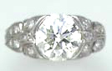
AN ART DECO DIAMOND AND PLATINUM RING
Description:
1 old European-cut diamond, gauged to weigh approximately 2.45 carats, I/J/K color, VVS-VS clarity, 16 circular and single-cut diamonds circa 1925, Size 7, repair evident, normal signs of wear

Pre-Auction Price Estimate: $8,000 - $10,000; Price Realized: $8,963
Christie's : New York: Mid Atlantic; Auction Date: Feb 11, 2004

9. Lot 141: DIAMOND RING
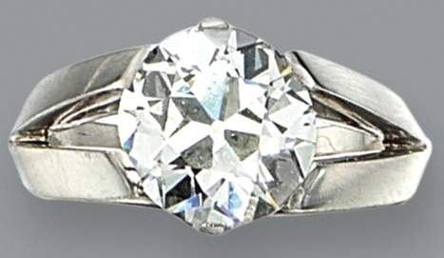
The old European-cut diamond weighing 3.84 carats, prong-set within a platinum band, size 8½.
Accompanied by GIA report no. 14785451 stating that the diamond is G color, VS1 clarity; together with original working diagram stating that the stone may be improvable. Estimate: $35,000 - $45,000; Realized: $62,400
Sotheby's : New York: Mid Atlantic; Auction Date: Apr 25, 2006

Sales of Art Deco Platinum Brooches

Art Deco Brooches

1. Lot 2115: Art Deco Platinum and Diamond Wreath Brooch
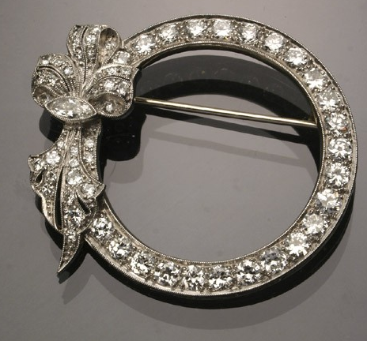
Circa 1930
Set with fifty-eight graduated round old European-cut diamonds weighing approximately 3.60 carats and one marquise diamond weighing approximately .20 carats.
Total weight of diamonds: 3.80 carats
Diameter: 1-1/2 in (3.8 cm)
Estimate: $3,500 - $4,500; Realized: $3,600
Weschler's : District of Columbia: Mid Atlantic; Auction Date: Apr 1, 2006

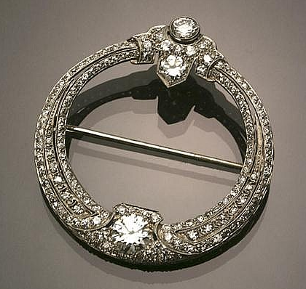
2. Lot 224: Art Deco Platinum and Diamond Wreath Brooch circa 1920-1930
Set with one round old European-cut diamond weighing approximately 1.05 carats, two smaller round old European-cut diamonds weighing approximately .80 carats and fifty graduated round old European and single-cut diamonds weighing approximately 2 carats. Total weight of diamonds: 3.85 carats Diameter: 1-1/2 inches (3.8 cm)
Estimate: $4,000 - $6,000; Realized: $6,000
Weschler's : District of Columbia: Mid Atlantic; Auction Date: Apr 21, 2007

3. Lot 334: Art Deco Platinum and Diamond Circle Brooch
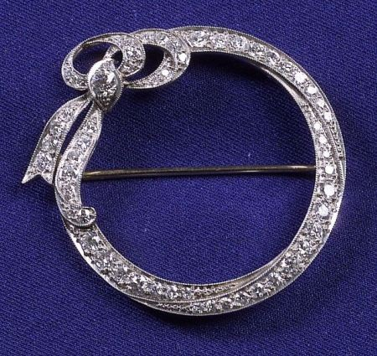
Set with fifty-five bead-set single and old European-cut diamond melee, millegrain highlights, (replaced pinstem).
Estimate: $1,000 - $1,500
Realized: $1,410
Skinner, Inc. : Massachusetts: New England
Auction Date: Mar 15, 2005

4. Lot 323 : ART DECO DIAMOND CIRCLE BROOCH, VAN CLEEF & ARPELS, PARIS, CIRCA 1930
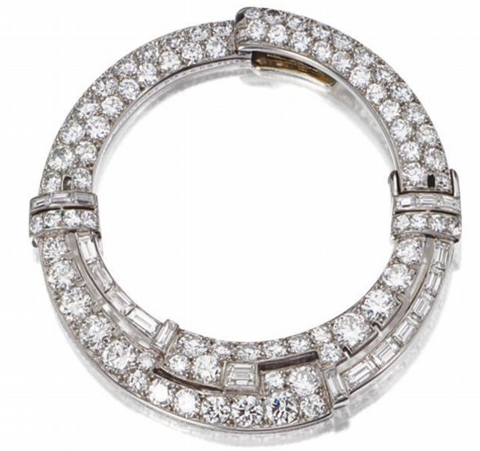
PROPERTY FROM A PRIVATE COLLECTION
The hinged circle decorated with 79 round and 19 baguette diamonds weighing approximately 8.15 carats, mounted in platinum, signed Van Cleef & Arpels, Paris, numbered 35482, assay marks.
Similar circle clips by Van Cleef & Arpels are illustrated by Sylvie Raulet, Van Cleef & Arpels, p. 1
Estimate: $7,500 - $10,000; Realized: $13,800
Sotheby’s: New York: Mid Atlantic; Auction Date: Dec 6, 2006

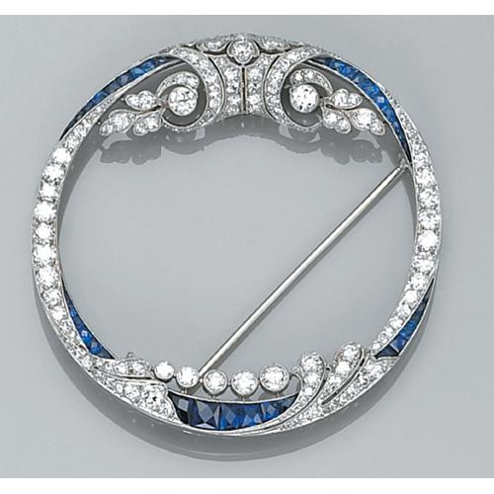
5. Lot 352: an art deco sapphire, diamond and platinum brooch, C.D. Peacock

An art deco sapphire, diamond and platinum brooch, C.D. Peacock
the slightly oval-shaped circle brooch, designed with scroll and foliate forms set with transitional-cut round diamonds, highlighted by Swiss and calibre-cut sapphires; estimated total diamond weight: 3.50 carats. Signed Peacock.

Estimate: $3,000 - $5,000; Realized: $6,110
Butterfield's Auctioneers Corp: California: West; Auction Date: Apr 27, 2004

6. Lot 377: A GROUP OF DIAMOND, EMERALD, PLATINUM AND WHITE GOLD
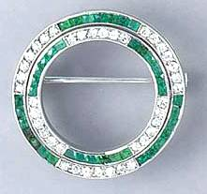
A GROUP OF DIAMOND, EMERALD, PLATINUM AND WHITE GOLD JEWELRY Comprising an Art Deco emerald, diamond and platinum circle brooch, (illustrated), circa 1925 An Art Deco diamond and platinum clasp, 2 old European-cut diamonds, each weighing approximately 0.65 carat, H/I/J color, VVS-SI clarity, circa 1920 And a circular-cut diamond and white gold enhancer
Overall condition, good (3)
Estimate: $2,800 - $3,200; Realized: $3,585
Auction Date: Oct 16, 2003

7. Lot 214: Art Deco Platinum, Emerald, and Diamond Circle Brooch
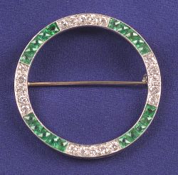
Alternating bead-set old European-cut diamonds with French-cut emeralds approx. total wt. 0.40 cts, gold pin stem.
Estimate: $1,000 - $1,500
Realized: $1,293
Skinner, Inc: Massachusetts: New England
Auction Date: Jun 15, 2004

8. Lot 340: AN ART DECO DIAMOND AND PLATINUM BROOCH
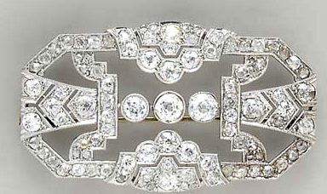
80 old mine and rose-cut diamonds, weighing approximately 9.00 carats total, ranging in color from H-M+, VS-SI clarity, circa 1925
Estimate: $3,500 - $4,500
Realized: $4,780
Christie's : New York: Mid Atlantic; Auction Date: Oct 13, 2004

9. Lot 45: AN ART DECO DIAMOND, PLATINUM AND WHITE GOLD BROOCH
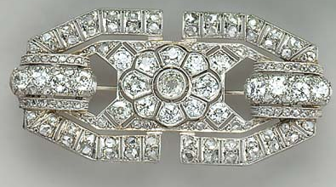
21 old European-cut diamonds, gauged to weigh approximately 3.25-3.75 carats total, H/I color, center diamond is K/L/M color, VS-SI clarity 100 rose-cut diamonds, incalculable due to cut, I/J/K color, SI-I clarity, circa 1925, in a brown leather fitted case (wear evident), repair evident, normal signs of wear
Estimate: $1,500 - $2,000; Realized: $2,629
Christie’s: New York: Mid Atlantic; Auction Date: Sep 14, 2004

10. Lot 231: Art Deco Tested Platinum and 18-Karat Yellow-Gold, Diamond and Ruby Brooch
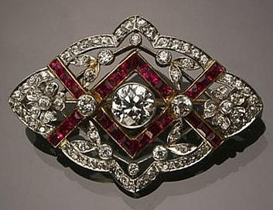
Circa 1930
Set with one round old European-cut diamond weighing approximately .85 carats, surrounded by seventy- [...more]
Estimate: $4,000 - $6,000
Realized: $4,200
District of Columbia: Mid Atlantic; Auction Date: Apr 21, 2007

11. Lot 263: AN ART DECO DIAMOND, SAPPHIRE, PLATINUM AND 14 K WHITE GOLD BROOCHES
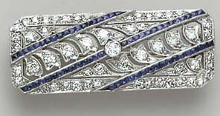
53 old European and circular-cut diamonds, gauged to weigh approximately 1.60 carats total, H/I color, VVS-VS clarity; 60 French-cut sapphires
Circa 1925
Estimate: $1,200 - $1,500; Realized: $1,912
Christie’s: New York: Mid Atlantic; Auction Date: Sep 14, 2004

12. Lot 640: an art deco diamond, emerald and platinum brooch
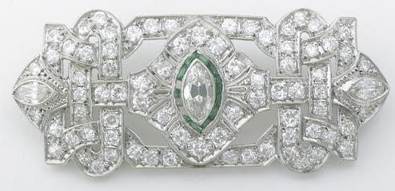
An art deco diamond, emerald and platinum brooch of rectangular shape, centering a bezel-set marquise-cut diamond framed by calibré-cut emeralds, further set throughout with transitional round brilliant and marquise-cut diamonds; estimated total diamond weight: 2.50 carats.
Estimate: $1,500 - $2,000
Realized: $2,938
Butterfield’s Auctioneers Corp. : California: West; Auction Date: Jun 29, 2004

13. Lot 543: An Art Deco Diamond and Platinum Brooch
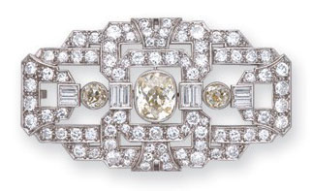
the openwork plaque centered by an old mine-cut diamond weighing approximately 1.80 carats, collet-set amid a geometric surround further embellished with baguette and old-cut diamonds totaling approximately 5.60 carats, in platinum
Estimate: CAD 5,000 - CAD 6,000
Realized: $4,962 CAD 6,500
Dupuis : Ontario: Canada; Auction Date: Jun 19, 2006

14. Lot 3570: Art Deco Aquamarine and Diamond Pendant Brooch
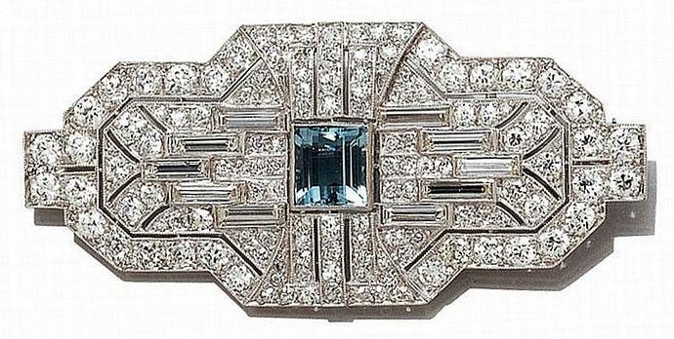
Platinum, the modified geometric pierced plaque centering one rectangular-cut aquamarine, approximately 1.50 cts flanked by 10 baguette diamonds, set throughout with 114 old European-cut diamonds, totaling approximately 6.85 cts. circa 1930, approximately 11.8 dwt.
Estimate: $4,800 - $5,200
Realized: $7,200
Doyle New York : New York: Mid Atlantic; Auction Date: Dec 5, 2006

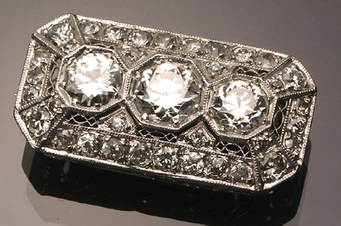
15. Auction Date : Jun 19, 2006 Art Deco Platinum and Diamond Bar Pin-Pendant
Circa 1920-1930
Set with three large round old European-cut diamonds, the center one weighing 1 carat, flanked by two smaller round old European-cut diamonds, each weighing approximately .70 carats and surrounded by thirty-four round old European and old mine-cut diamonds weighing approximately 1.50 carats. Length: 1-1/4 in (3.2 cm) Width: 1/2 in (1.25 cm)
Estimate: $4,000 - $6,000; Realized: $4,200
Weschler's : District of Columbia: Mid Atlantic; Auction Date: Dec 3, 2005

16. Lot 563: BROCHE ART DECO DIAMANTS
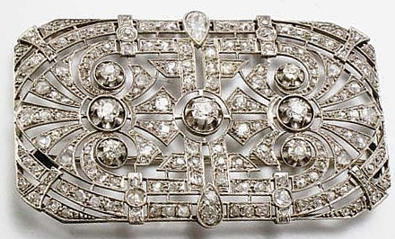
De forme rectangulaire, ajourée d'un décor serti de diamants ronds et taillés en rose rehaussé de sept diamants taille ancienne plus importants et un diamant poire au centre, monture en platine, épingle en or gris
Estimate : € 800 - € 1,200;; Realized : € 1,260
Christie's; Auction Date : Dec 19, 200

17. Lot 2319 : ART DECO, DIAMOND, GREEN STONE, PLATINUM BROOCH
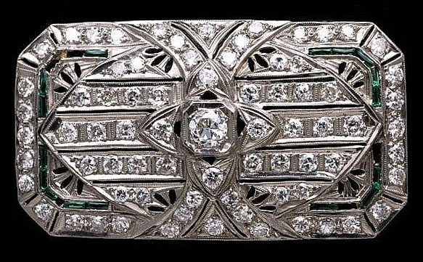 | 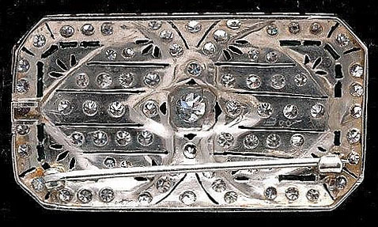 | 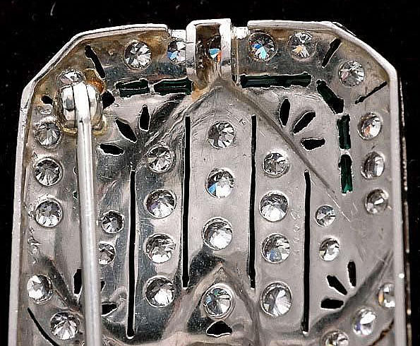
ART DECO, DIAMOND, GREEN STONE, PLATINUM BROOCH, centering one old European-cut diamond, weighing approximately 0.20 carat, accented by seventy-four old European cut diamonds, weighing a total of approximately 2.50 carats, further enhanced by thirteen caliber cut green stones, bead and channel set in a pierced, engraved and millegrained platinum rectangular mounting, measuring approximately 54 x 25 mm. Total weight 7.7 dwts. {Note: stones missing, missing pendant bail} Doyle New York : New York : Mid Atlantic
Auction Date : Dec 5, 2006

18. Lot 513: Art Deco Platinum and Diamond Brooch
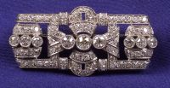
Bezel-set with nine old European-cut diamonds, approx. total wt. 1.17 cts further highlighted by seventy-six bead-set single-cut diamonds, millegrain accents.
Estimate: $1,500 - $2,500; Realized: $1,763; Skinner, Inc. : Massachusetts: New England; Auction Date: Sep 21, 2004

19. Lot 640A: Art Deco Platinum and Diamond Pendant/Brooch

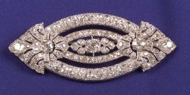
The navette set with five old mine and European-cut diamonds weighing approx. 5.33 cts. further surrounded by 142 bead-set old mine and European-cut dias weighing approx. 13.32 cts., approx. total wt. for all diamonds, 18.65 cts. Note: Accompanied by original sketch by designer, Edmond Frisch, 336 Park Avenue, New York.
Estimate: $10,000 - $15,000; Realized: $9,988
Skinner, Inc. : Massachusetts: New England; Auction Date: Jun 15, 2004

20. Lot 105: ART DECO DIAMOND AND SAPPHIRE BROOCH, FRENCH, CIRCA 1920

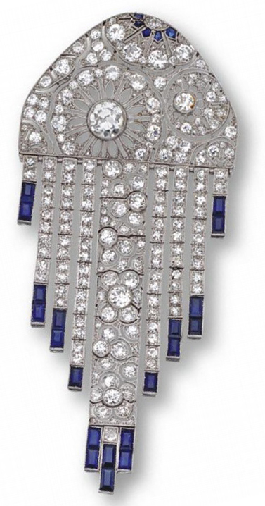
Designed as an openwork panel decorated with stylized flowers supporting graduating articulated fringes, set with an old European-cut diamond weighing approximately 1.30 carats and numerous smaller old European-cut, single-cut and rose-cut diamonds weighing approximately 10.00 carats, the fringes anchored by calibré-cut sapphires, mounted in platinum, French assay marks and maker's mark.
Estimate: $15,000 - $20,000; Realized: $20,400
Sotheby's : New York: Mid Atlantic; Auction Date: Dec 6, 2006

21. Lot 228: Art Deco Platinum, Diamond and Emerald Brooch
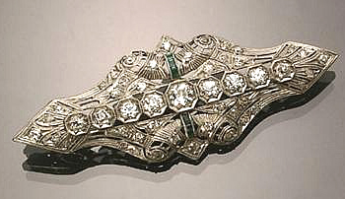
Circa 1920-1930
set with forty-nine round old European, old mine and single-cut diamonds weighing approximately 2.65 carats and six square-cut emeralds weighing approximately .20 carats. Length: 2-1/2 inches (6.4 cm) Width: 1 inch (2.5 cm)
Estimate: $2,000 - $3,000; Realized: $1,400; Weschler's : District of Columbia: Mid Atlantic; Auction Date: Apr 21, 2007

22. Lot 143: Art Deco Platinum and Diamond Bow-Knot Brooch
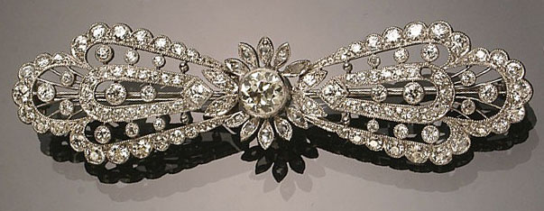
Circa 1930
Set with one round old European-cut diamond weighing approximately .70 carats, surrounded by ten rose-cut diamonds, flanked by one h [...more]
Estimate: $3,000 - $5,000
Realized: $3,000
Weschler's : District of Columbia: Mid Atlantic

23. Lot 3698: Art Deco Diamond and Black Onyx Bow Brooch

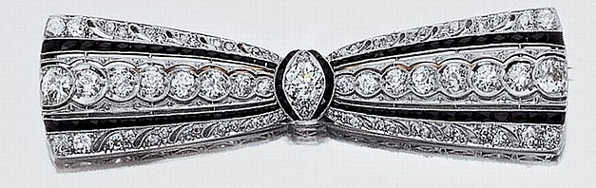
Platinum, the pierced bow centering one old European-cut diamond, approximately .50 ct., flanked by 16 old European-cut diamonds, edged by 54 small old European-cut diamonds, altogether approximately 3.10 cts., accented by numerous calibre-cut black onyx, signed G & C Co. for Greenleaf & Crosby, circa 1920, approximately 10.9 dwt. Diamonds: Center diamond, H-VS. Rest, G-H-VS. Length 2 7/8"
Estimate $5,000-7,000; Realized: $5,000
Doyle New York : New York: Mid Atlantic; Auction Date: Dec 2, 2006

24. Lot 159: ART DECO, EMERALD, DIAMOND, PLATINUM, 14K BAR PIN
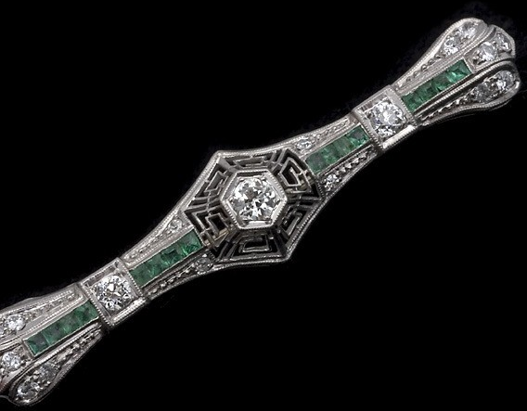
ART DECO, EMERALD, DIAMOND, PLATINUM, 14K WHITE GOLD BAR BROOCH. Centering one old European-cut diamond, flanked by two old European-cut diamonds, weighing a total of approximately 0.40 carats, accented by sixteen square-cut emeralds, weighing a total of approximately 0.40 carats, enhanced by sixteen old cut diamonds, weighing a total of approximately 0.25 carats, bead and channel set in an open work bar mounting, measuring approximately 55 x 12 mm. Gross weight 6.3 grams.
Estimate: $600 - $800; Realized: $500
Auctions by the Bay : California: West; Auction Date: May 2, 2005

25. Lot 224: Art Deco Filigree Platinum and Diamond Bar Pin Circa 1920
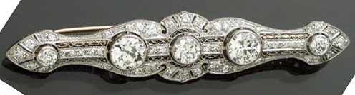
Set with three large round old European cut diamonds, the center diamond weighing approximately.75 carats, flanked by two larger round old European cut diamonds one weighing approximately 1.35 carats, the other weighing approximately 1.55 carats. Surrounded by fifty-two round old European and single cut diamonds weighing approximately 2.35 carats Total weight of diamonds: 6 carats Length: 3 in (7.6 cm).
Estimate: $7,000 - $10,000; Realized: $9,200
Weschler's : District of Columbia: Mid Atlantic; Auction Date: Sep 14, 2002

26. Lot 331: Art Deco Bar Pin
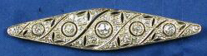
The openwork navette-shape pin bezel and bead-set with thirty-two old mine and old single-cut diamonds, millegrain accents, platinum mount, Continental hallmarks
Estimate: $800 - $1,000
Realized: $881
Skinner, Inc. : Massachusetts: New England
Auction Date: Mar 18, 2003

27. Lot 227: Art Deco Blue Sapphire and Diamond Bar Pin

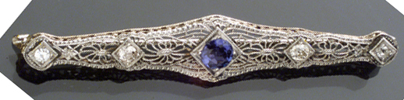
Art Deco 14-Karat White Gold and Filigree Platinum Top

Circa 1930 Set with one round faceted sapphire weighing approximately.55 carats and four old mine cut diamonds weighing approximately.30 carats. Length: 2-1/2 in (6.4 cm).
Estimate: $400 - $600; Realized: $316

28. Lot 132: Art Deco Filigree Platinum and Diamond Bar Pin Circa 1920-1930
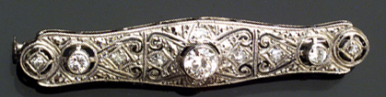
Set with one round old European cut diamond weighing approximately.35 carats flanked by two smaller round old European cut diamonds weighing approximately.10 carats alternating with six single cut diamonds weighing approximately.12 carats. Total weight of diamonds: 0.57 carats Length: 2 in (5.1 cm).
Estimate: $1,000 - $1,500; Realized: $805
Weschler's : District of Columbia: Mid Atlantic; Auction Date: Dec 14, 2002

29. Lot 3404: Art Deco Diamond and Black Onyx Bar Brooch
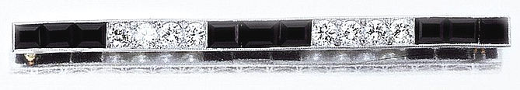
Platinum, gold, 8 diamonds appx. 1.60 cts, signed Tiffany & Co., c. 1920, appx. 5.5 dwt. Diamonds: I-J-VS. Length 3 1/8"
Estimate: $2,500 - $3,500; Realized: $3,000

Doyle New York : New York: Mid Atlantic;
Auction Date: Dec 5, 2006

30. Lot 4: Platinum Art Deco Bar Pin
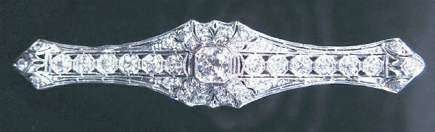
35 diamonds - Old European Cut - (1).50 ct F-G SI, - (12).05 ct, (16).02 ct, (6).03 ct - (1.60 cts total weight). Excellent condition. Estimate: $2,500 - $3,500; Realized: $1,650
Ken Farmer Auctions & Appraisals LLC : Virginia: Southeast; Auction Date: Jun 6, 2004

31. Lot 473: An Art Deco Diamond and Platinum Brooch
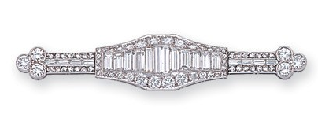
the bar form designed as a graduating course of baguette-cut diamonds collet-set within a millegrained surround of round diamonds, to the diamond ribbons and trefoil finials, altogether the diamonds weighing approximately 5.80 carats, in platinum
Estimate: CAD 5,000 - CAD 6,000
Realized: $6,107 CAD 8,000
Dupuis : Ontario: Canada
Auction Date: Jun 19, 2006

32. Lot 304: An art deco diamond, emerald and platinum bar pin
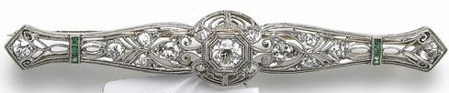
An art deco diamond, emerald and platinum bar pin
the openwork brooch set with European-cut diamonds, accented by calibre-cut emeralds; estimated total diamond weight: 1.00 carat.
Estimate: $800 - $1,200; Realized: $1,116
Butterfield’s Auctioneers Corp. : California: West; Auction Date: Apr 27, 2004

Internet Resources
http://gia.edu/reportcheck/
http://209.85.173.104/search?q=cache:MFSr_tQh-http://www.agslab.com/products_report.php
http://12.45.15.232/igiweb/onlinereport/
http://www.theleodiamond.com/Diamonds.asp
http://www.antiquorum.com/
http://ashford.com/shop/watches.asp?N=140+112
http://bernardwatch.com
http://collectorstime.com
www.jewelave.com
http://www.wannabuyawatch.com/vintageswiss1.html
http://wristwatch.com/
http://www.bogoff.com/wrist/wrist.html
www.finertimes.com
www.worldofwatches.com
http://www.time4less.net/watches
The first four are to look up laser inscribed diamonds by GIA (for certs later than 2005) AGS and IGI certs (if an IGI cert isn't on the site, an appraiser can call IGI 212-847-3323 which is the direct line to a very helpful person who will give you carat weight, color and clarity from the cert off their computer).

Diamonds from Leo Schachter which are sold in Sterling Corporation stores are lasered “Leo” and a reference number that can be entered, and the IGI cert will appear. For those of us who want to look these up - especially for correct carat weights - and want to be accurate, this is the way to go.

Other helpful sites:
http://www.pricescope.com
http://www.artfact.com
http://www.gubelinlab.com/index.asp
http://www.agta-gtc.org/index.html
http://www.ruby-sapphire.com/r-s-bk-ch5.htm
http://research.amnh.org/earthplan/research/Projects/geh-rubies
http://www.palagems.com/learning_vault.htm
http://www.aigslaboratory.com/aigsbeblue.php
http://www.palagems.com/flux_healing.htm
http://www.peretti.ch/video.htm (Gem Research Swisslab videos)

