Prepared for:  ,  Phone:  Email: | ,  Phone:  Date of Appraisal: 7/29/26  Replacement cost as of:
This appraisal was made to provide an expert opinion of the Replacement Cost (New) of a assumed to be wholly owned by as represented by the client. This appraisal is intended for use only by the client and the client’s insurer in securing insurance for the item.
Replacement Cost (New) is defined by as "The client’s current cost to purchase or have constructed, through , a new equivalent replacement property."
For readily available items, is the market used as the basis of the appraisal in the sales comparison approach. For custom created items the client’s cost to have a duplicate item created through is the basis used in the cost approach.
This item was examined by the undersigned appraiser on using instruments and methods generally accepted by the trade. It was sold to the customer on for , including sales tax (copy attached), and no changes have occurred in the market since then to change the replacement cost.
The item was not purchased from this store.
examined by the undersigned appraiser on using instruments and methods generally accepted by the trade. It was sold to the customer on for , including sales tax (copy attached), and no changes have occurred in the market since then to change the replacement cost.

Stock #:  Weight: grams dwt  Condition:  Manufacture:  Period:  Notes: | Dimensions: mm x x mm high  Quality Stamp:  Trademark:  Setting:  Shank: mm wide, mm thick, style  Size:  Engraved:
Center Diamond: cut measuring approximately x x mm, ct, color, clarity, depth , table , with proportions. lab report
Center : cut measuring approximately x x mm, ct, color, clarity, bulge, window, extinction, with proportions. lab report
Side : cut measuring approximately x x mm, ct total ( ) color, clarity, proportions
Accent : cut measuring approximately mm, total-weight ( ) color, clarity, proportions
Replacement Cost (New) including sales tax:

for
Certification & Oath
I hereby certify that to the best of my knowledge and belief:
- Statements of fact contained in this report are true and correct. These are my personal, unbiased opinions and conclusions are limited only by the reported assumptions and limiting conditions.
- I have personally examined the jewelry that is the subject of this report. Anyone providing significant professional assistance in preparing this appraisal is stated in the report.
- I have no undisclosed present, or contemplated future, interest in the jewelry described that would bias the report. I do not have any unspecified personal interest or bias with respect to the parties involved. My compensation is not contingent upon the attainment of a stipulated result, or the occurrence of a subsequent event. It is not contingent upon reporting a predetermined value or a direction in value that would favor the cause of the client.
- I swear that I have truly, honestly and impartially appraised the described property to the best of my ability, and hereto sign this oath.

________________________________
Attachments:
Copy of the sales receipt
Lab reports
Warranty for
______________
Photographs

Professional Profile

GIA Diamond Grading Nomenclature
Color
Color | D | E | F | G | H | I | J | K | L | M | N | O | P | Q | R | S | T | U | V | W | X | Y | Z | Fancy
Scale | Colorless |  |  | Near Colorless |  |  |  | Faint Yellow |  |  | Very Light Yellow |  |  |  |  | <------Light Yellow------> |  |  |  |  |  |  |  | Color

Clarity
Clarity | FL | IF | VVS¹ | VVS² | VS¹ | VS² | SI¹ | SI² | I¹ | I² | I³
Scale | Flawless-  Internally Flawless |  | Very, Very Slightly Included |  | Very Slightly Included |  | Slightly Included |  | Imperfect

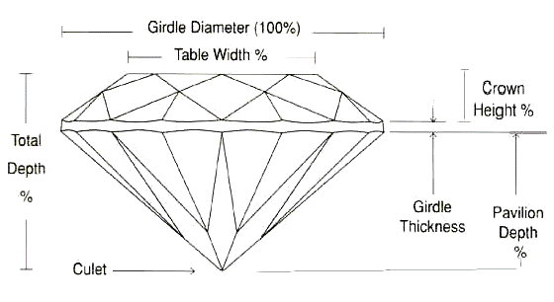
Cut
Super-Ideal Exceeds Ideal proportions [e.g. Hearts & Arrows pattern]
Ideal Meets GIA Ideal proportions
Very good Standard for fine cut
Good Slight cutting faults
Fair Serious cutting faults
Poor Major cutting faults
Note: cutting faults affect the ability of the diamond to achieve its full potential of beauty

